ACOUSTICAL WOOD SLATS

Ecological acoustic panel made of wooden slats
Acoustic wood slat wall panels offer premium, state-of-the-art wood solutions. Each panel can visually transform a project, but also can create a calmer and more comfortable environment.
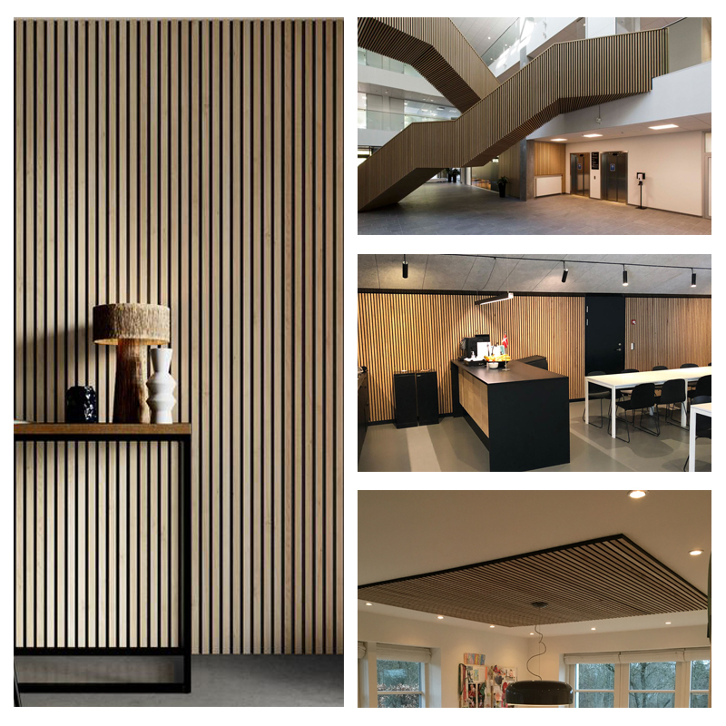

TECHNICAL DETAILS

Spécification:

- Regular size: 605mm x 2440mm / 600mm x 2400mm /
- 610mm x 2743 (product code 1525-108)
- Thickness: 21mm / 10mm
- Space between wooden slats: 15mm / 13mm
- Width of wooden slats: 25mm / 27mm
- Polyester felt panels : 9mm/12mm (density 143kg/m3)

Space between wooden slats, width of slats

Product code : 1525

Product code : 1327

COLOR CHART
